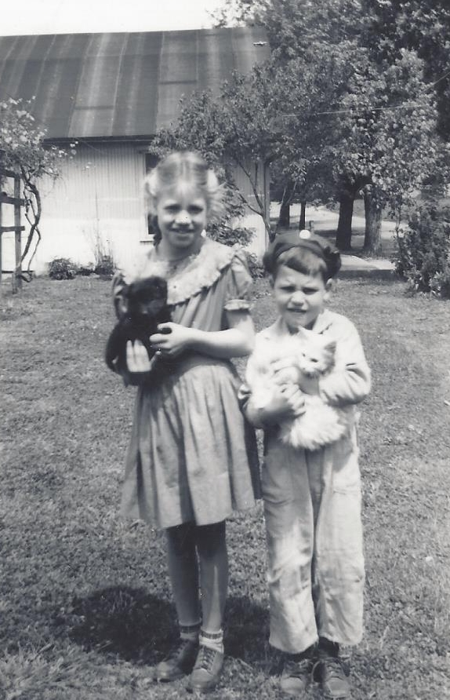

Mary Jo & John Wolfe - Kingston - 1945

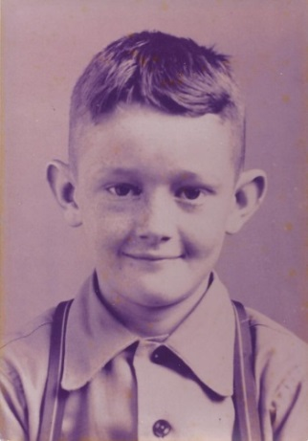

Andrew Jackson “Jack” Moore – 1943